Research & Solutions

**Bharath**  
**Link**: [84.51° Exec: What to Expect from Consumers and How to Achieve Omnichannel Success in 2024](https://www.emarketer.com/content/84-51-exec-what-expect-consumers-how-achieve-omnichannel-success-2024)  
**Description**: Consumers still have concerns about inflation, leading to cost-conscious behaviors, such as looking for more deals, cutting back on non-essentials, and trading down to lower-cost (private label) brands. A big emphasis is placed on **personalization** to target deal-seekers effectively. The omnichannel experience combines in-store discovery and inspiration with online convenience. The strategy needs to integrate both channels for mutual enhancement.

**Key Insight**: National brands should focus on personalized promotions, while private labels should prioritize marketing product quality to build brand loyalty. The strategy must be long-term, extending beyond the inflationary period.

**Bharath** : [Importance of Consumer Behaviour : Understanding the Buying Mind](https://www.youtube.com/watch?v=s-t-PqOaX1E)

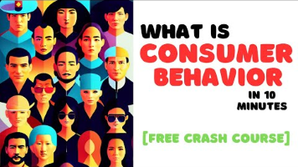

**Summary**: Understanding consumer behaviors allows companies to tailor their products, services, and strategies to foster customer growth. Predicting market trends, such as the growing interest in health and wellness, can help companies stay ahead by marketing relevant items. Retention is key, and personalized offers can encourage repeat purchases.

Bharath: Factors that influence consumer behavior: [5 Factors Influencing Consumer Behaviour (+ Buying Decisions)](https://www.youtube.com/watch?v=Hi_RZzxBfFw)

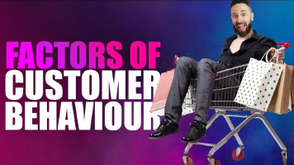

**Summary**:

* **Psychological Factors**: Motivation, perception, and education play a crucial role. Perception is everything in branding (important for private labels), and educating consumers about the brand leads to a better experience and loyalty.
* **Social Factors**: Family influence can create lifelong brand loyalty if introduced early.
* **Economic Factors**: Disposable income dictates spending behavior.

**Potential Solutions**

1. **Deaverage Pricing**: For important growth drivers, minimize price increases to hold or gain market share. For slower-growing profit generators, raise prices above inflation to maximize contribution, even at the risk of losing share.
2. **Shelf Price Increases**: Current market conditions support raising shelf prices, which allows CPG players to selectively reinvest in trade spending, such as coupons.

[A Pricing Playbook for CPG Companies Amid Inflationary Pressure | BCG](https://www.bcg.com/publications/2021/pricing-playbook-for-cpg-companies)

**Notes**: A three-tier solution includes deaveraging prices, increasing shelf prices, and offering personalized coupons or bundled coupons. Personalized coupons targeted to specific consumer types (household categories) can create an optimal product mix that drives sales in an inflationary environment by incentivizing consumers to buy additional (more elastic) products while earning coupons for their core (inelastic) products.

**Additional Research**

**Pricing Moves for CPG in a Cost-of-Living Crisis**: Consumers are changing their buying behavior—spending more on nondiscretionary categories like gas and utilities, while trading down in discretionary categories. CPG companies have responded by increasing prices and reducing package sizes, which have shown a significant short-term impact. Approximately 60% of CPG companies have done this in the past 18 months (article published 1/3/23)

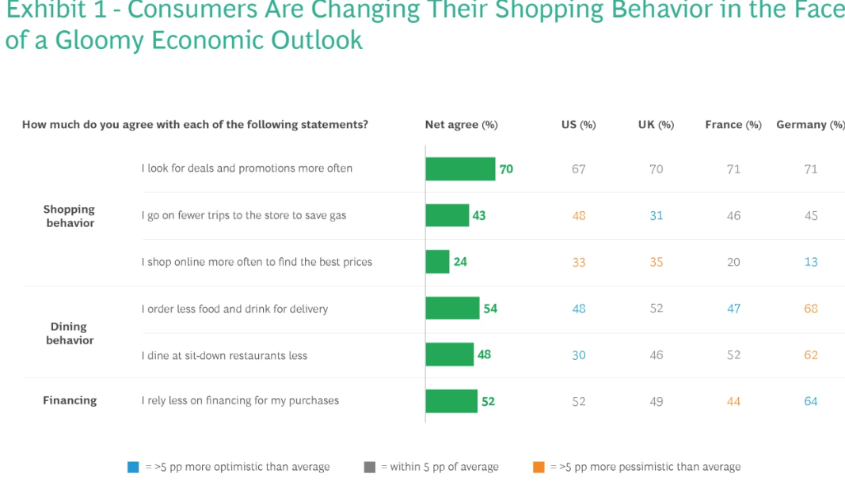

**5 NRM Imperatives for CPGs to Win Today and Tomorrow**:

* Integrate future-facing consumer perspectives.
* Synchronize assortment, portfolio simplification, and value engineering efforts.
* Evaluate NRM levers holistically.
* Take the retailer’s perspective into account.
* Clean up inefficient legacy trade terms.

**Related Articles**:

* [**Five Pricing Moves for CPG in a Cost-of-Living Crisis**](https://www.bcg.com)
* [**Tracking Grocery Prices: CPG Inflation Slows, but Consumer Spending Power Still a Concern**](https://nielseniq.com)
* **USDA ERS - U.S. Consumers Spent More on Food in 2022 Than Ever Before, Even After Adjusting for Inflation**